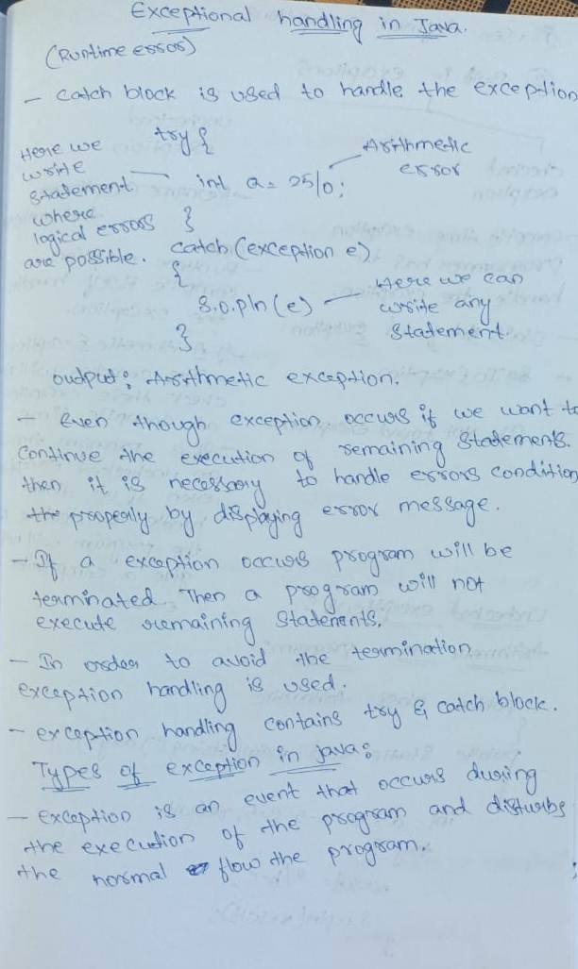

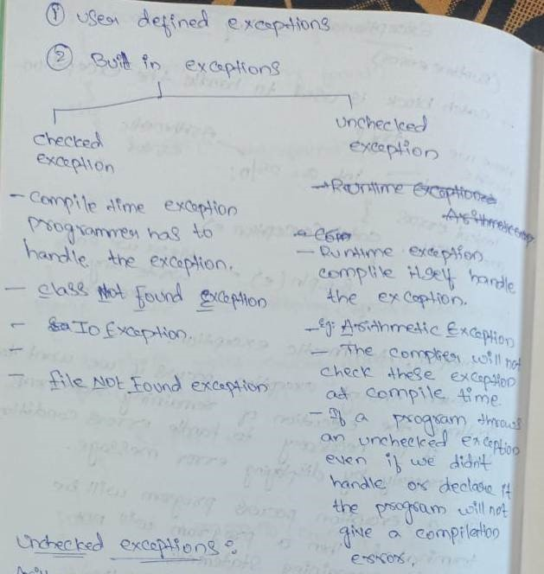

Array index exception:

package p1;
import java.util.Scanner;
public class ExceptionHandling {
public static void main(String args[])
{
Scanner sc=new Scanner(System.in);
try
{
int b[]=new int[5]; System.out.println(b[6]);
}
catch(ArrayIndexOutOfBoundsException e) {
System.out.println(e);
}
System.out.println("rest of the code...");

}
}

Null Pointer Exception:
package p1;

import java.util.Scanner;

public class NulpointerException
{

public static void main(String args[])
{
Scanner sc=new Scanner(System.in);
try {
String s=null;
System.out.println(s.length());
}
catch(NullPointerException e) {
System.out.println(e);
}
System.out.println("rest of the code...");

}
}

NumberFormatException:

package p1;
public class Numberformatexception
{
public static void main(String args[])
{
try
{
String s="CSE24STUDENTSARENOTPERFECT";
// NumberFormatException
int i=Integer.parseInt(s);
}
catch(NumberFormatException e)
{
System.out.println(e);
}
System.out.println("rest of the code...");
}
}

